**Vaccine System**

*Developer Guide*

|  |  |  |
| --- | --- | --- |
| **Supervisor.** | **Sir Hassan Nadeem** | |
| **Batch.** | **2202B1** | |
| **Group.** | D | |
| **Serial No.** | **Enrollment Number** | **Student Name** |
| 1. | Student1364025 | Muhamamd Umer Ejaz |
| 2. | Student1364030 | Hussain aiman |
| 3. | Student1364862 | |  | | --- | | SYED MUHAMMAD OSIJA RAZA RIZVI | |  | |
| 4. | Student1364026 | MUHAMMAD MOIZ . |

1. **Home** (*Home.php*)



***Figure 1: Home page to Vaccine Booking System***

**Code of Home page**

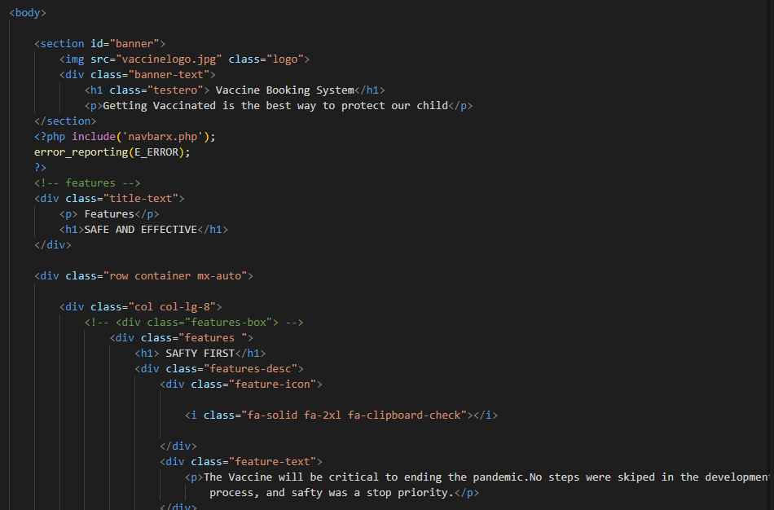

1. **Navbar (home.php)**

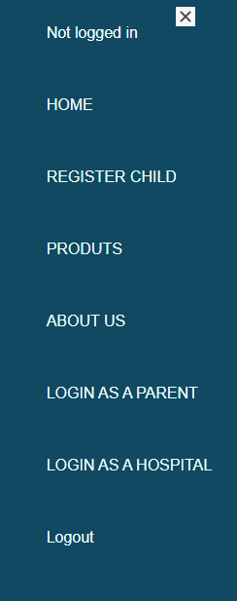

***Figure 2: Navbar***

**Code of Navbar**

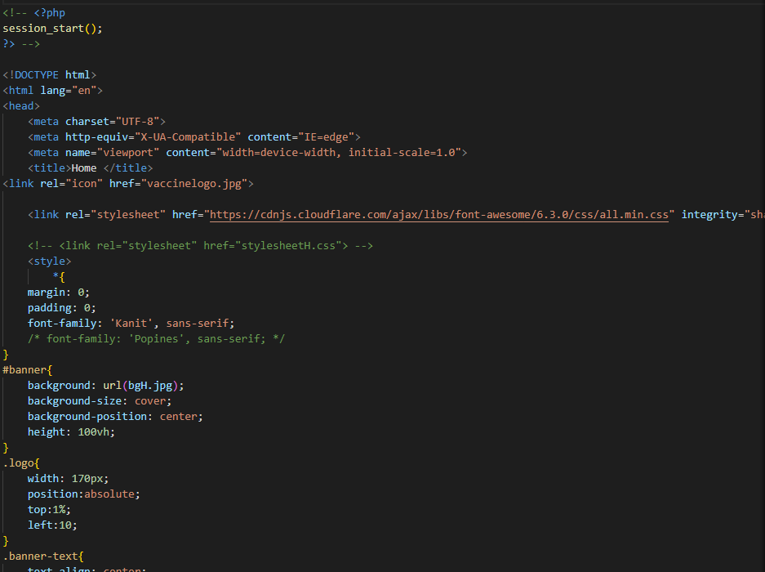

1. **About us (about.php)**



 ***Figure 3: About us***

***Code o********f About Us*** 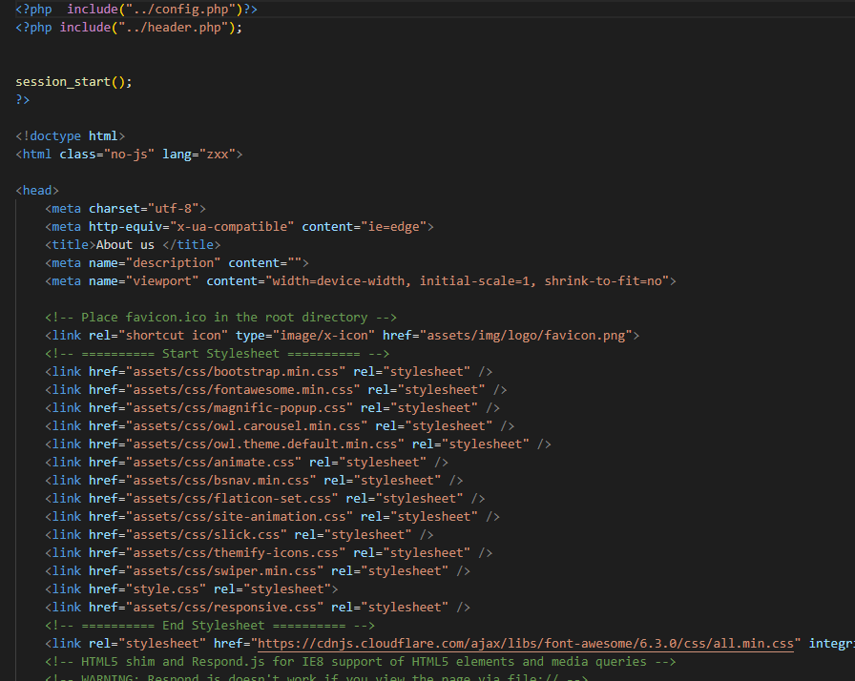

**Service (index (1).html)**

***Figure 4: Service***

*We have mentioned our basic services to make people known about the service we*